**Index**

|  |  |  |
| --- | --- | --- |
| **Chapter No.** | **Particulars** | **Page Number** |
| **1** | **INTRODUCTION** | **3** |
| 1.1 | ABSTRACT | 3 |
| 1.2 | EXISTING SYSTEM AND LIMITATIONS OF THE EXISTING SYSTEM | 4 |
| 1.3 | NEED FOR THE PROPOSED SYSTEM | 5 |
| 1.4 | SCOPE OF SYSTEM | 6 |
| 1.5 | BRIEF DESCRIPTION OF TECHNOLOGY USED 1.6.1 OPERATING SYSTEMS USED (WINDOWS OR UNIX) 1.6.2 DATABASE (IF APPLICABLE) | 7 |
| **2** | **PROPOSED SYSTEM** | **8** |
| 2.1 | STUDY OF SIMILAR SYSTEMS | 8 |
| 2.2 | FEASIBILITY STUDY | 9 |
| 2.3 | OBJECTIVES OF PROPOSED SYSTEM | 10 |
| 2.4 | FUNCTIONAL AND NON-FUNCTIONAL REQUIREMENTS | 12 |
| 2.5 | USERS OF SYSTEM | 14 |
| 2.6 | MODULE SPECIFICATION | 15 |
| **3** | **SYSTEM ANALYSIS AND DESIGN** | **17** |
| 3.1 | ENTITY RELATIONSHIP DIAGRAM | 17 |
| 3.2 | USE CASE DIAGRAM | 18 |
| 3.3 | CLASS DIAGRAM | 19 |
| 3.4 | SEQUENCE DIAGRAM | 20 |
| 3.5 | ACTIVITY DIAGRAM | 21 |
| 3.6 | MODULE HIERARCHY DIAGRAM | 22 |
| 3.7 | COMPONENT DIAGRAM | 23 |
| 3.8 | DEPLOYMENT DIAGRAM | 24 |
| 3.9 | WEB SITE MAP DIAGRAM | 25 |
| 3.10 | TABLE SPECIFICATION [DATA DICTIONARY] | 26 |
| 3.11 | USER INTERFACE DESIGN AND REPORTS | 29 |
| **4** | **DRAWBACKS AND LIMITATION** | **32** |
| **5** | **PROPOSED ENHANCEMENT** | **33** |
| **6** | **CONCLUSION** | **34** |
| **7** | **BIBLIOGRAPHY** | **35** |
| **8** | **ANNEXURES** | **36** |
| **9** | **SAMPLE CODE** | **39** |

**1.1 INTRODUCTION :**

**1.1 Abstract :**

The proposed Online Pet Shop Management System in PHP is designed to streamline the management of a pet shop's operations, including the management of pet information, services offered, and customer transactions.

**Pet Information Management:**The system allows for the registration of pets, including their breed, age, gender, and vaccine schedules. This information is critical for ensuring the health and well-being of the pets in the shop. The system also enables the tracking of pet inventory, making it easier to manage stock levels and reorder supplies when necessary.

**Service Offerings:**The system includes a range of services that can be offered to customers, such as cleaning, scissoring, bathing, and blow-drying. These services can be scheduled and managed through the system, ensuring that appointments are organized, and staff are aware of the services required for each pet.

**Customer Transactions:**The system simplifies the process of transacting with customers, allowing for the gathering of customer information and the management of payments. This makes it easier for customers to make purchases and for the pet shop to manage its finances.Search Functionality:The system includes a search function that allows users to easily find the information they need. This can include searching for specific pets, services, or customer information.

**Systematic Functionality:**The system is designed to operate systematically, ensuring that all pet information is correct and organized. This is important for avoiding problems such as bad feedback from customers, which can damage the reputation of the pet shop.

**User-Friendly Design:The** system is designed to be user-friendly, making it easy for staff to manage pet information, schedule services, and manage customer transactions.

This can help to reduce errors and improve efficiency, leading to a better customer experience.Overall, the proposed Online Pet Shop Management System in PHP is designed to simplify and streamline the operations of a pet shop, making it easier to manage pet information, services, and customer transactions.

By organizing and automating these processes, the system can help to improve efficiency, reduce errors, and enhance the customer experience.

**1.2 EXISTING SYSTEM AND LIMITATIONS OF THE EXISTING SYSTEM :**

1. Limited Geographical Reach: The physical store restricts the reach of the pets shop to the local area, limiting the customer base and potential sales.
2. Manual pets Management: Pets management is often done manually, leading to inaccuracies, stock outs, and difficulties in tracking product availability.
3. Limited Product Visibility: Customers can only view and purchase products available in the physical store, reducing their choices and potentially missing out on popular or specialized items.
4. Inefficient Order Processing: Order processing is often time-consuming and prone to errors since it involves manual entry, tracking, and fulfillment.
5. Lack of Integrated Payment System: The existing system may not have a secure and integrated payment gateway, requiring customers to make payments through offline methods, which can be inconvenient and less secure.
6. Limited Customer Interaction: Customer interactions are primarily face-to-face or through traditional communication channels, making it challenging to provide timely assistance or personalized services.
7. Lack of Sales Monitoring and Analytic: There is a lack of systematic sales monitoring and analysis, which hinders the ability to track performance, identify trends, and make data-driven business decisions

These limitations highlight the need for a more robust and efficient online pets shop management system in PHP to overcome these challenges and enhance the overall shopping experience for customers.

* 1. **NEED FOR THE PROPOSED SYSTEM :**
  2. Expanded Customer Reach: The proposed system will provide an online platform that extends the reach of the pets shop beyond its physical location. It allows customers from anywhere to browse and purchase pets and pet-related products, leading to an expanded customer base and increased sales potential.
  3. Enhanced Convenience: The proposed system offers customers the convenience of browsing and shopping for pets and pet-related products from the comfort of their own homes. It eliminates the need for them to visit the physical store, saving time and effort.
  4. Automated Inventory Management: The proposed system automates inventory management processes, ensuring real-time updates on product availability. This reduces stockouts, eliminates manual errors, and improves overall inventory accuracy.
  5. Streamlined Order Processing: The proposed system streamlines the order processing and fulfillment process. Customers can easily place orders, choose delivery options, and track the status of their purchases. This improves efficiency, reduces errors, and enhances customer satisfaction.
  6. Secure Online Transactions: The proposed system integrates a secure payment gateway, enabling customers to make online transactions with confidence. It protects their payment information and ensures secure and seamless payment processing.
  7. Personalized Customer Experience: The proposed system allows for personalized customer experiences. Customers can create accounts, save their preferences, and receive personalized recommendations based on their previous purchases and browsing history.
  8. Sales Monitoring and Analytic: The proposed system provides robust sales monitoring and analytic capabilities. It generates reports and insights on sales performance, customer behavior, and product popularity. This enables data-driven decision-making and helps identify trends and opportunities.
  9. **Scope of the System :**

1. Pet Management: The system will allow pet shop owners to manage their Pets of pets, including adding new pets, updating pet details, tracking availability, and removing sold or adopted pets from the inventory.
2. Customer Management: The system will facilitate customer registration, login, and profile management. It will also enable pet shop owners to maintain customer records, track their orders, and communicate with them.
3. Online Catalog and Search: The system will provide an online catalog of pets, allowing customers to browse and search for pets based on various criteria such as breed, age, gender, or price range. It will display detailed information about each pet, including descriptions and images.
4. Booking and Adoption: Customers will have the ability to book or adopt pets online through the system. They can select a pet, provide their contact information, and specify any preferences or requirements. The system will facilitate the booking or adoption process and update the inventory accordingly.
5. Order Management: The system will allow pet shop owners to manage customer orders. They can view and process orders, update order statuses, generate invoices or receipts, and track the progress of each order.
6. Administrative Backend: The system will include an administrative backend that allows the pet shop owner to manage system settings, user accounts, and access various reports and analytics. This backend will provide administrative control over the system's functionalities and configurations.

# BRIEF DESCRIPTION OF TECHNOLOGY USED :

### Software Requirement:

* **Front End**:
  + HTML: For creating the structure and content of web pages.
  + CSS: For styling and formatting the appearance of web pages.
  + JavaScript: For implementing interactive features and dynamic behavior on the client-side.
* **Server**:
  + Apache Tomcat: As the web server to host and serve the web application.
* **Back End**:
  + PHP: As the server-side scripting language for processing user requests, managing data, and interacting with the database.
* **Database**:
  + MySQL: As the relational database management system (RDBMS) for storing quiz questions, user information, and other relevant data.
* **Browser Compatibility:** The system should be compatible with popular web browsers such as Chrome, Firefox, Safari, and Edge.

### Hardware Requirement:

* **Processor**:
  + Windows 11: Operating system to run the web server, database server, and other necessary software components.
* **RAM**:
  + 8 GB: Sufficient memory to handle concurrent user requests, database operations, and server-side processing.
* **ROM**:
  + 128 GB: Adequate storage space for hosting the web application files, database files, and other system resources.

# 2.PROPOSED SYSTEM :

**2.1. STUDY OF SIMILAR SYSTEMS:**

• **User Interface and Experience**: Evaluate the user interface of the Pet Shop Management System to understand how it facilitates easy navigation, intuitive interactions, and efficient management of pet-related activities. Look for features that enhance user experience, such as a clear layout, informative dashboards, and streamlined workflows.

• **Functionality and Features**: Identify the core functionalities and features offered by the Pet Shop Management System, such as inventory management, customer management, sales tracking, appointment scheduling, and reporting. Determine how these features are implemented and integrated to meet the needs of pet shop owners, staff, and customers.

• **Data Management**: Examine how data is stored, organized, and managed within the Pet Shop Management System. Analyze the database schema, data models, and relationships between different entities (e.g., pets, customers, suppliers, transactions) to understand the underlying data structure and its scalability, flexibility, and efficiency.

• **Integration and Connectivity**: Assess the system's ability to integrate with external services, platforms, and devices, such as payment gateways, inventory management systems, online marketplaces, and IoT devices. Explore how data is exchanged and synchronized between the Pet Shop Management System and other systems to ensure seamless connectivity and interoperability.

• **Security and Privacy**: Investigate the security measures and privacy protections implemented in the Pet Shop Management System to safeguard sensitive information, such as customer data, financial transactions, and business records. Look for features like access control, encryption, audit trails, and compliance with regulatory requirements (e.g., GDPR, HIPAA).

• **Scalability and Performance**: Evaluate the scalability and performance of the Pet Shop Management System to handle growing volumes of data, users, and transactions over time. Assess factors such as system responsiveness, uptime, latency, throughput, and resource utilization under varying load conditions.

• **Customization and Extensibility**: Determine the system's flexibility and extensibility to accommodate unique requirements and adapt to changing business needs. Explore options for customization, configuration, and integration of third-party plugins, modules, or extensions to enhance the functionality and scalability of the system.

**2.2** **Feasibility Study**

• **Market Analysis**:

* Identify the target market for the Pet Shop Management System, including pet shop owners, staff, and customers.
* Analyze the demand for pet shop management solutions in the market.
* Evaluate the competition and existing solutions available in the market.

• **Technical Feasibility**:

* Assess the technical requirements and constraints for developing the Pet Shop Management System.
* Evaluate the availability of necessary technologies and tools for system development, such as programming languages, frameworks, and databases.
* Determine the feasibility of integrating with existing systems or platforms used by pet shops.

• **Operational Feasibility**:

* Evaluate how the Pet Shop Management System will fit into the daily operations of pet shops.
* Assess the willingness of pet shop owners and staff to adopt and use the system.
* Consider any potential resistance to change and strategies for overcoming it.

• **Legal and Regulatory Compliance**:

* Identify any legal or regulatory requirements that the Pet Shop Management System must comply with, such as data protection laws (e.g., GDPR), industry standards, and pet-related regulations.
* Assess the potential risks and liabilities associated with non-compliance and develop strategies for ensuring legal and regulatory compliance.

• **Resource and Time Constraints**:

* Evaluate the availability of resources, including skilled personnel, time, and budget, for developing the Pet Shop Management System.
* Identify any potential risks or challenges that could impact the project timeline and resource allocation.
* Develop a project plan with realistic milestones, timelines, and resource allocations.

• **Risk Analysis**:

* Identify potential risks and uncertainties that could affect the success of the project, such as technical challenges, market competition, and changes in customer preferences.
* Assess the likelihood and impact of each risk and develop mitigation strategies to minimize their effects.

**2.3 Objectives Of Proposed System**

• **Streamline Operations**:

* Automate routine tasks such as inventory management, sales tracking, and appointment scheduling to reduce manual effort and improve efficiency.
* Simplify administrative processes such as pet registration, customer management, and billing to save time and resources.

• **Improve Customer Service**:

* Provide a user-friendly interface for customers to browse products, schedule appointments, and make purchases online.
* Offer personalized services such as pet grooming reminders, vaccination schedules, and pet health tips to enhance customer experience and satisfaction.
* Enable quick and efficient communication between pet shop staff and customers for inquiries, reservations, and feedback.

• **Enhance Inventory Management**:

* Maintain accurate records of pet supplies, food, medications, and accessories in stock to prevent overstocking or stockouts.
* Set up automatic alerts for low inventory levels, expiring products, and upcoming deliveries to ensure timely replenishment.
* Track product sales, trends, and customer preferences to optimize inventory purchasing and stocking decisions.

• **Facilitate Financial Management**:

* Generate invoices, receipts, and financial reports to track sales, expenses, and profits accurately.
* Monitor accounts receivable, overdue payments, and expenses to maintain financial stability and cash flow.
* Integrate with accounting software or financial management systems for seamless data transfer and reconciliation.

• **Enhance Marketing and Promotions**:

* Analyze customer purchase history, preferences, and demographics to create targeted marketing campaigns and promotions.
* Implement loyalty programs, discounts, and special offers to incentivize repeat purchases and customer loyalty.
* Utilize social media integration, email marketing, and online advertising to reach a wider audience and attract new customers.

• **Ensure Regulatory Compliance**:

* Adhere to legal and regulatory requirements related to pet care, product labeling, licensing, and data protection.
* Maintain accurate records of pet health, vaccinations, and medical history to comply with veterinary regulations and standards.
* Implement security measures to protect sensitive customer information and ensure data privacy and confidentiality.

• **Enable Business Growth and Expansion**:

* Provide scalability and flexibility to accommodate the growth and expansion of pet shop operations.
* Support multi-location management, franchise operations, and online sales channels to reach new markets and increase revenue.
* Continuously update and improve the Pet Shop Management System based on feedback, market trends, and technological advancements to stay competitive and meet evolving business needs.

**2.4. FUNCTIONAL AND NON-FUNCTIONAL REQUIREMENTS :**

### Functional Requirements:

1. **User Authentication and Authorization**:
   * Users should be able to register, log in, and log out securely.
   * Different roles (admin, staff, customer) should have appropriate access rights.
2. **Product Management**:
   * Add, edit, delete pet products with details such as name, category, price, quantity, etc.
   * Manage inventory levels and track stock availability.
3. **Customer Management**:
   * Maintain customer profiles with details like name, contact information, pet details, etc.
   * Allow customers to update their profiles and view past purchases.
4. **Sales and Billing**:
   * Process sales transactions, generate invoices, and receipts.
   * Calculate taxes, discounts, and total amounts accurately.
5. **Appointment Scheduling**:
   * Allow customers to schedule appointments for services like pet grooming, veterinary check-ups, etc.
   * Manage appointment slots, availability, and staff schedules.
6. **Reporting and Analytics**:
   * Generate reports on sales performance, inventory status, customer trends, etc.
   * Provide analytics to identify popular products, peak sales periods, etc.
7. **Integration with Payment Gateway**:
   * Enable secure online payments through integration with popular payment gateways.
   * Support various payment methods like credit/debit cards, PayPal, etc.

### Non-Functional Requirements:

1. **Performance**:
   * Ensure fast response times for all system operations, even during peak load times.
   * Handle multiple concurrent users without performance degradation.
2. **Security**:
   * Implement robust authentication mechanisms to prevent unauthorized access.
   * Encrypt sensitive data such as customer information and payment details.
   * Regularly update security patches and conduct security audits to identify vulnerabilities.
3. **Reliability**:
   * Ensure high availability and uptime of the system.
   * Implement backup and disaster recovery mechanisms to prevent data loss.
4. **Usability**:
   * Design a user-friendly interface with intuitive navigation and clear instructions.
   * Provide help documentation and tutorials to assist users in using the system.
5. **Scalability**:
   * Design the system architecture to accommodate growth in data volume and user traffic.
   * Support scalability through cloud hosting or scalable infrastructure.
6. **Compatibility**:
   * Ensure compatibility with different web browsers and devices (desktops, laptops, tablets, smartphones).
   * Support multiple operating systems such as Windows, macOS, and Linux.
7. **Regulatory Compliance**:
   * Adhere to legal and regulatory requirements related to data privacy, consumer protection, and payment processing.
   * Comply with industry standards and best practices for pet care, product labeling, etc.
8. **Maintainability**:
   * Write clean, well-documented code following coding standards and best practices.
   * Implement modular design and code reusability to facilitate future updates and maintenance.

**2.5 USERS OF SYSTEM :**

• **Admin**:

* The admin has full control over the system.
* Responsibilities include managing products, customers, staff, inventory, and overall system settings.
* Access to all features and functionalities of the system, including reporting and analytics.
* Can create, edit, or delete other user accounts and assign roles.

• **Staff**:

* Staff members work at the pet shop and interact with customers directly.
* Responsibilities include managing sales, processing orders, scheduling appointments, and assisting customers with inquiries.
* Limited access to certain administrative functions like managing products and customers.
* Can view and update customer profiles, process transactions, and schedule appointments.

• **Customers**:

* Customers are pet owners who visit the pet shop for various services and products.
* Responsibilities include browsing products, making purchases, scheduling appointments, and updating their profiles.
* Can view product listings, place orders, schedule appointments for pet services, and update their contact and pet information.
* Access to features like viewing order history, tracking order status, and providing feedback.
  1. **MODULE SPECIFICATION :**

**User Management Module:**

* User Registration: Allows customers to register and create an account.
* User Login: Enables customers and administrators to log into the system.
* Profile Management: Allows users to update their profile information.

**Pet Inventory Management Module**:

* Add Pet: Enables pet shop owners to add new pets to the inventory.
* Update Pet Details: Allows pet shop owners to update pet information such as breed, age, price, and availability.
* Remove Pet: Enables pet shop owners to remove pets from the inventory when they are sold or adopted

**Catalog and Search Module:**

* Pet Listing: Displays a catalog of available pets, including their details and images.
* Search Functionality: Allows customers to search for pets based on various criteria such as breed, age, gender, or price range.
* Filtering Options: Provides filtering options to refine search results.

**Booking and Adoption Module:**

* Pet Booking: Enables customers to book a pet by providing their contact information and specifying preferences.
* Adoption Process: Facilitates the adoption process by guiding customers through the required steps.
* Availability Update: Updates the pet's availability status after a booking or adoption is completed.

**Order Management Module:**

* View Orders: Allows pet shop owners to view and manage customer orders.
* Order Status Update: Enables pet shop owners to update the status of orders (e.g., pending, in progress, delivered).
* Invoice Generation: Generates invoices or receipts for completed orders.

**Reporting and Analytics Module:**

* Sales Reports: Provides reports on sales performance, including revenue, popular breeds, and adoption trends.
* Inventory Reports: Generates reports on inventory status, including available pets, sold pets, and stock levels.
* Customer Analytics: Offers insights into customer behavior, preferences, and interactions.

**Administrative Backend Module:**

* System Settings: Allows administrators to manage system configurations and settings.
* User Management: Enables administrators to manage user accounts and permissions.
* Reports and Analytics: Provides access to various reports and analytics for administrators

**3. SYSTEM ANALYSIS AND DESIGN :**

**3.1 ENTITY RELATIONSHIP DIAGRAM :**

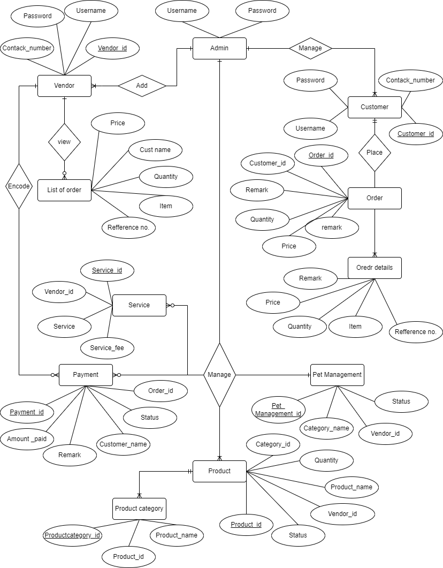

Order



Manage



* 1. **USE CASE DIAGRAM :**

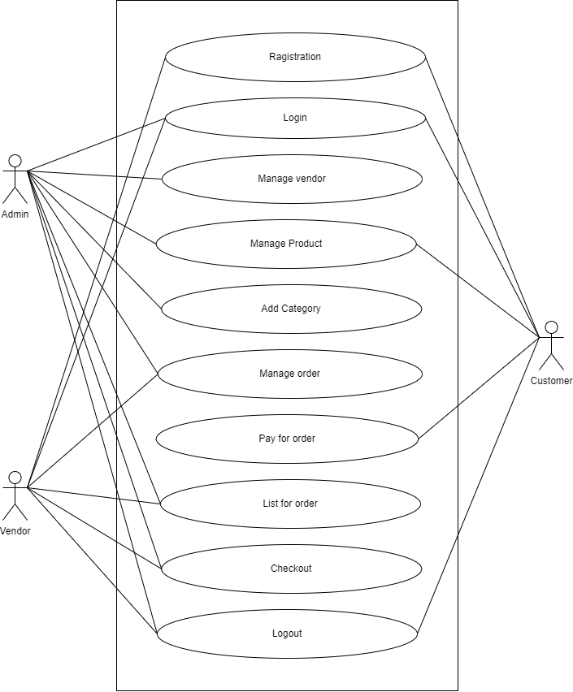

Registration



* 1. **CLASS DIAGRAM :**

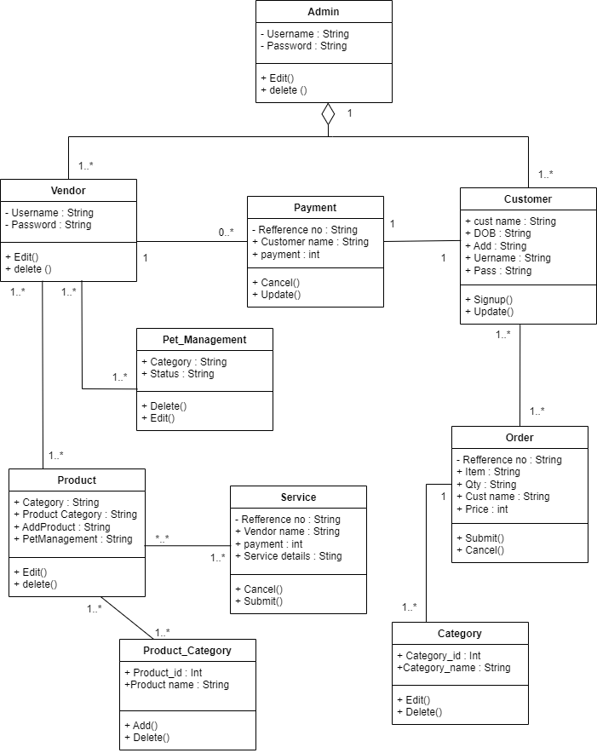

1--*

1--*



**3.4 SEQUENCE DIAGRAM :**

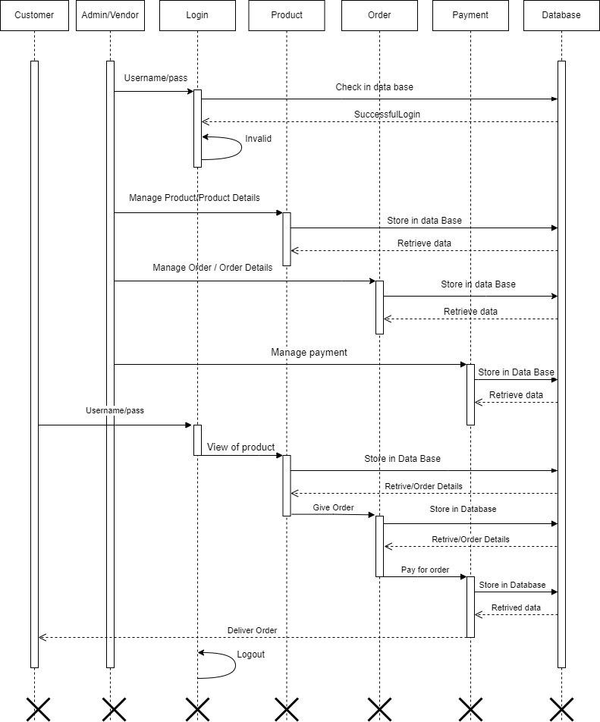

**3.5 ACTIVITY DIAGRAM :**

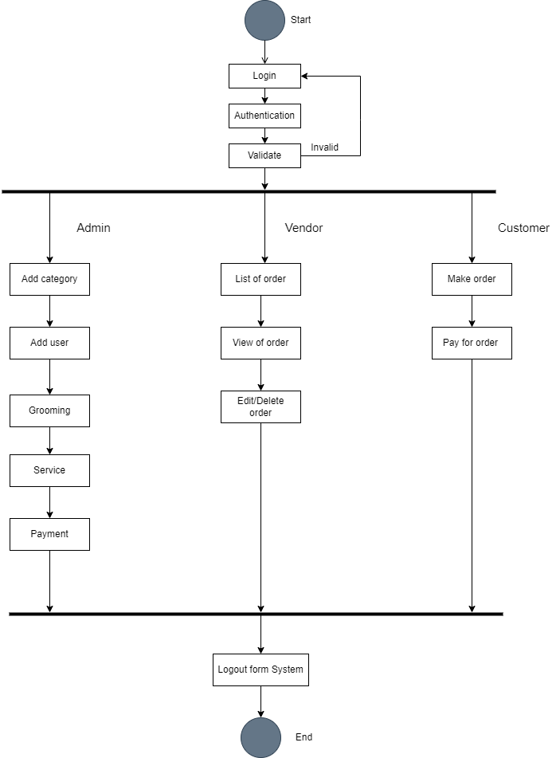

**3.6** **Module Hierarchy Diagram**:

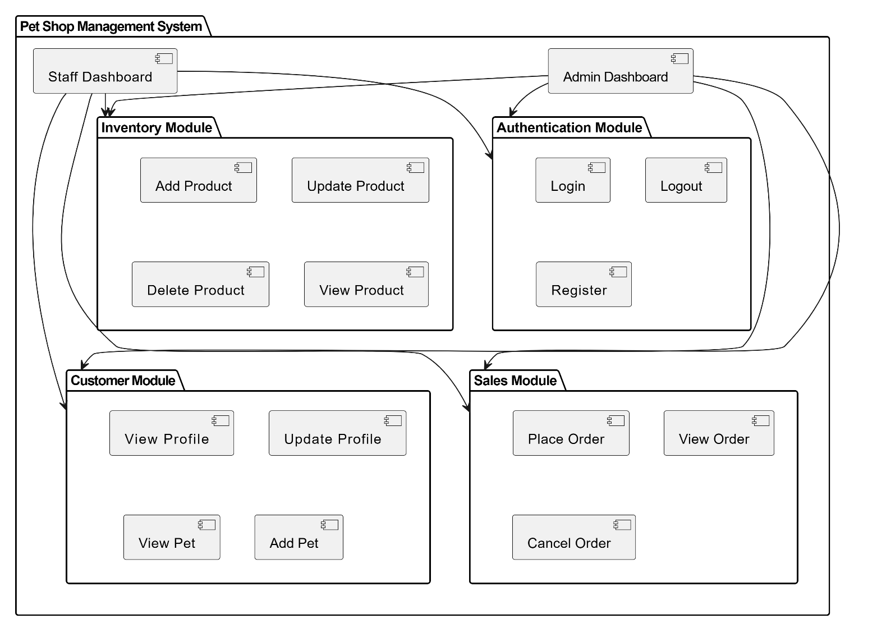

**3.7 COMPONENT DIAGRAM :**

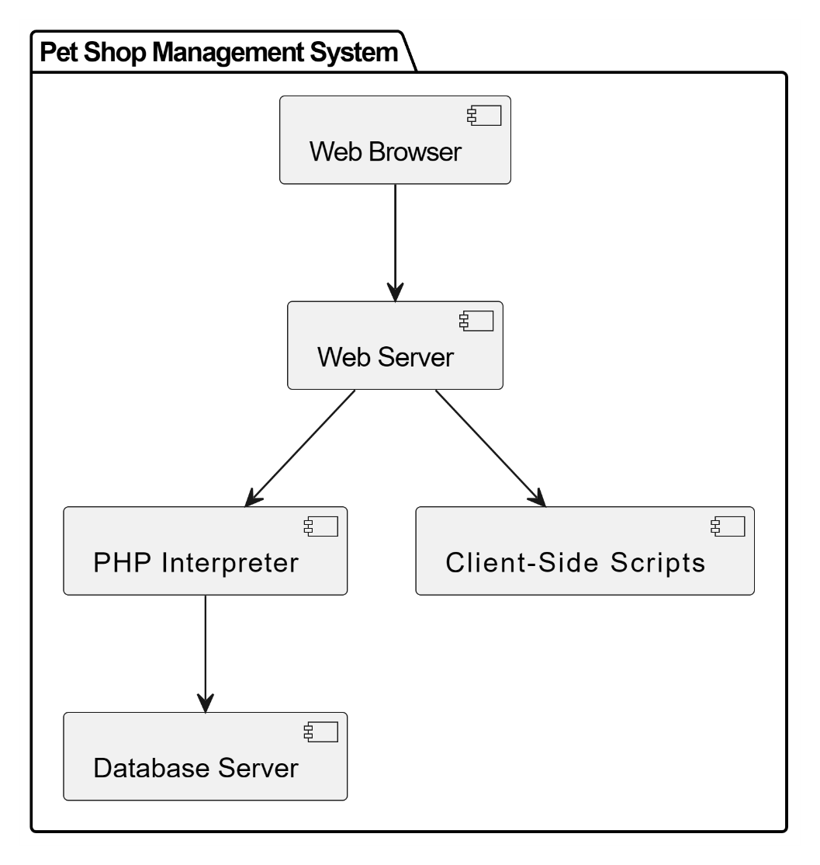

**3.8 DEPLOYMENT DIAGRAM :**

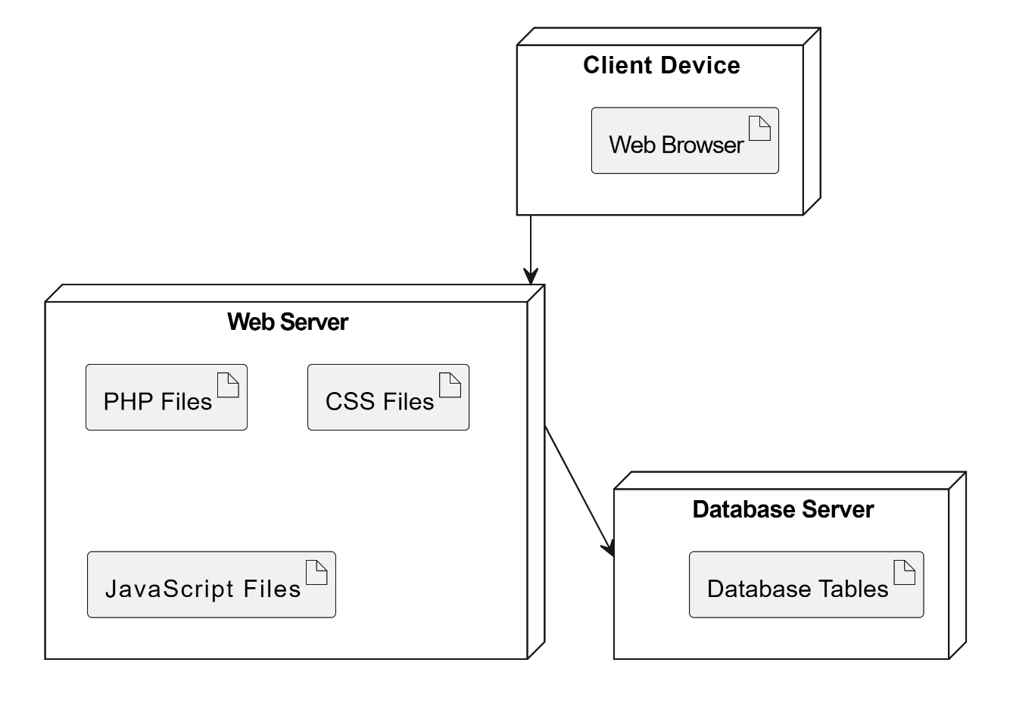

**3.9 WEB SITE MAP DIAGRAM :**

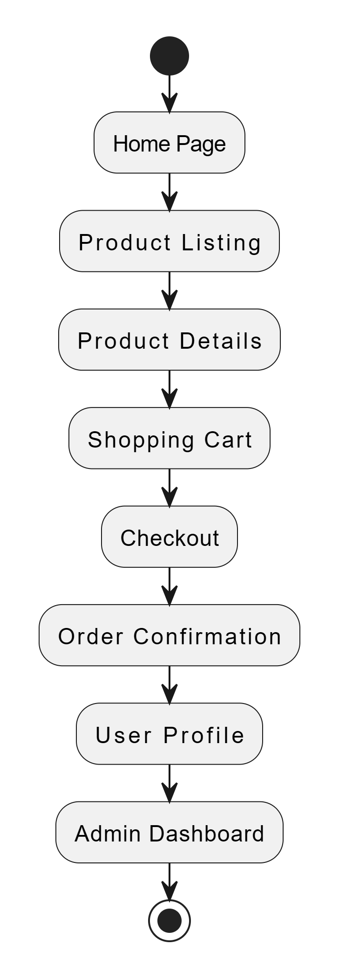

**3.10 TABLE SPECIFICATION :**

**Admin :**

|  |  |  |  |
| --- | --- | --- | --- |
| **Field** | **Type** | **Size** | **Constraints** |
| AUsername | VARCHAR | 25 | NOT NULL |
| APassword | VARCHAR | 25 | NOT NULL |

**Vendor :**

|  |  |  |  |
| --- | --- | --- | --- |
| **Field** | **Type** | **Size** | **Constraints** |
| Vendor_id | INT | 10 | PRIMARY KEY |
| Company_name | VARCHAR | 25 | NOT NULL |
| Contact_person | INT | 10 | NOT NULL |
| Company_email | VARCHAR | 20 | NOTNULL |
| Contact_number | INT | 10 | NOTNULL |
| website | VARCHAR | 25 | NOTNULL |
| About_company | VARCHAR | 25 | NOTNULL |
| username | VARCHAR | 10 | NOTNULL |
| password | INT | 10 | NOTNULL |

**Customer :**

|  |  |  |  |
| --- | --- | --- | --- |
| **Field** | **Type** | **Size** | **Constraints** |
| Customer_id | INT | 10 | PRIMARY KEY |
| First_name | VARCHAR | 200 | NOT NULL |
| Middle_name | VARCHAE | 200 | NOT NULL |
| Last_name | VARCHAR | 200 | NOT NULL |
| Complete_address | VARCHAR | 200 | NOT NULL |
| Email_address | VARCHAR | 200 | NOT NULL |
| Contact_number | VARCHAR | 200 | NOT NULL |
| Civil_status | VARCHAR | 200 | NOT NULL |
| age | VARCHAR | 3 | NOT NULL |

**Category :**

|  |  |  |  |
| --- | --- | --- | --- |
| **Field** | **Type** | **Size** | **Constraints** |
| Catrgory id | VARCHAR | 255 | PRIMARY KEY |
| Category name | VARCHAR | 255 | NOT NULL |

**Order :**

|  |  |  |  |
| --- | --- | --- | --- |
| **Field** | **Type** | **Size** | **Constraints** |
| Order_id | INT | 10 | PRIMARY KEY |
| Customer_id | VARCHAR | 25 | FOREGIN KEY |
| Customer_name | VARCHAR | 25 | NOT NULL |
| item | VARCHAR | 25 | NOT NULL |
| qty | INT | 10 | NOT NULL |
| price | INT | 8 | NOT NULL |
| status | VARCHAR | 20 | NOT NULL |
| remarks | INT | 20 | NOT NULL |
| Date_created | TEXT | 10 | NOT NULL |

**Payment :**

|  |  |  |  |
| --- | --- | --- | --- |
| **Field** | **Type** | **Size** | **Constraints** |
| Payment_id | INT | 10 | PRIMARY KEY |
| Order_id | INT | 10 | FOREGIN KEY |
| Amount_paid | INT | 10 | NOT NULL |
| Status | VARCHAR | 20 | NOT NULL |
| Remarks | VARCHAR | 20 | NOT NULL |
| Customers | VARCHAR | 25 | NOT NULL |
| Paid_key | INT | 10 | NOT NULL |
| Process_by | TEXT | 10 | NOT NULL |

**Pet Management:**

|  |  |  |  |
| --- | --- | --- | --- |
| **Field** | **Type** | **Size** | **Constraints** |
| Pet_management_id | INT | 10 | PRIMARY KEY |
| Description | VARCHAR | 25 | NOT NULL |
| Category _name | VARCHAR | 25 | NOT NULL |
| Vendor_id | VARCHAR | 20 | FOREGIN KEY |
| Status | VARCHAR | 20 | NOT NULL |
| Images | Text | 50 | NOT NULL |

**Product :**

|  |  |  |  |
| --- | --- | --- | --- |
| **Field** | **Type** | **Size** | **Constraints** |
| Product_id | INT | 10 | PRIMARY KEY |
| Product_code | INT | 10 | NOT NULL |
| Product_name | VARCHAR | 25 | NOT NULL |
| details | VARCHAR | 25 | NOT NULL |
| Category_id | VARCHAR | 25 | FOREGIN KEY |
| qty | INT | 10 | NOT NULL |
| Vendor_price | INT | 10 | NOT NULL |
| Retail_price | INT | 10 | NOT NULL |
| disc | VARCHAR | 25 | NOT NULL |
| Vendor_id | VARCHAR | 10 | FOREGIN KEY |
| Status | VARCHAR | 10 | NOT NULL |

**Product category :**

|  |  |  |  |
| --- | --- | --- | --- |
| **Field** | **Type** | **Size** | **Constraints** |
| Productcategory_id | INT | 10 | PRIMARY KEY |
| Product_id | INT | 10 | FOREGIN KEY |
| Product_name | VARCHAR | 25 | NOT NULL |

**Service :**

|  |  |  |  |
| --- | --- | --- | --- |
| **Field** | **Type** | **Size** | **Constraints** |
| Services_id | INT | 10 | PRIMARY KEY |
| Reference_no | INT | 10 | NOT NULL |
| Services | VARCHAR | 25 | NOT NULL |
| Services_detail | VARCHAR | 25 | NOT NULL |
| Vendor-id | VARCHAR | 25 | FOREGIN KEY |
| Service_fee | INT | 10 | NOT NULL |

**3.11 USER INTERFACE DESIGN AND REPORTS :**

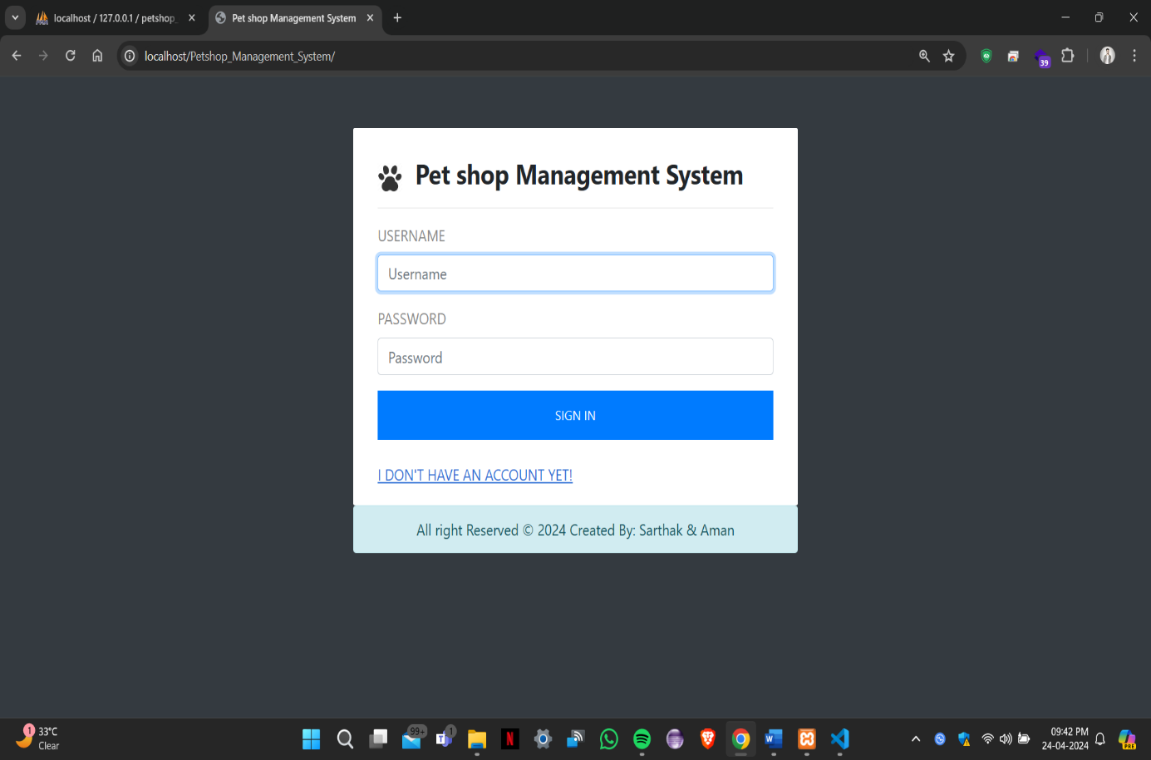

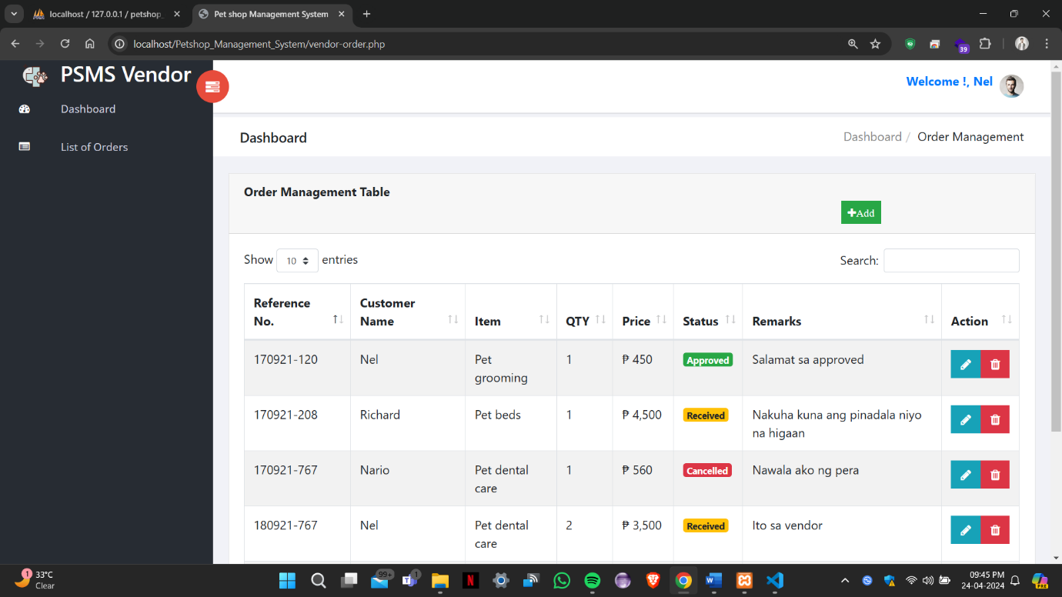

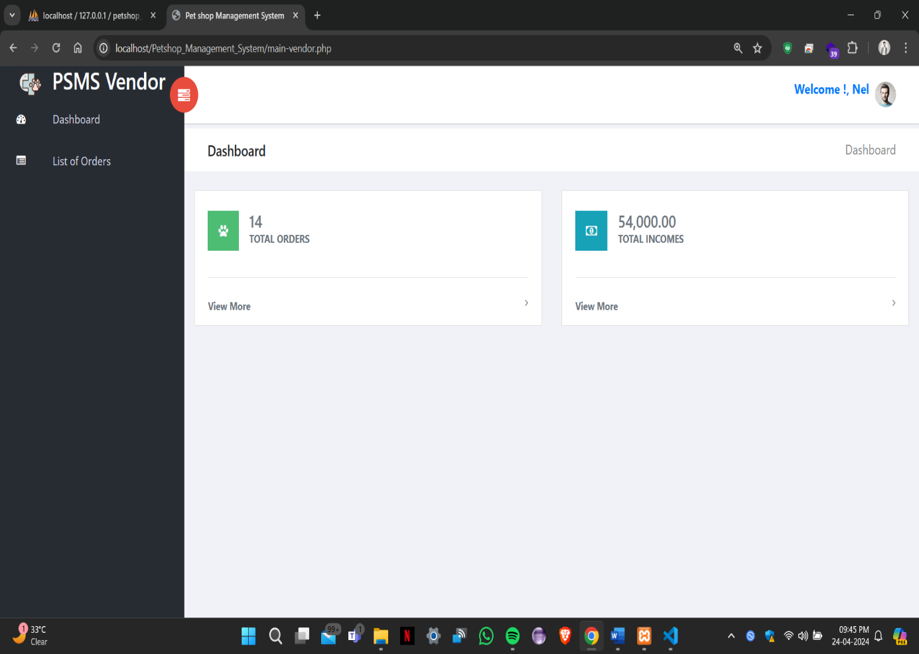

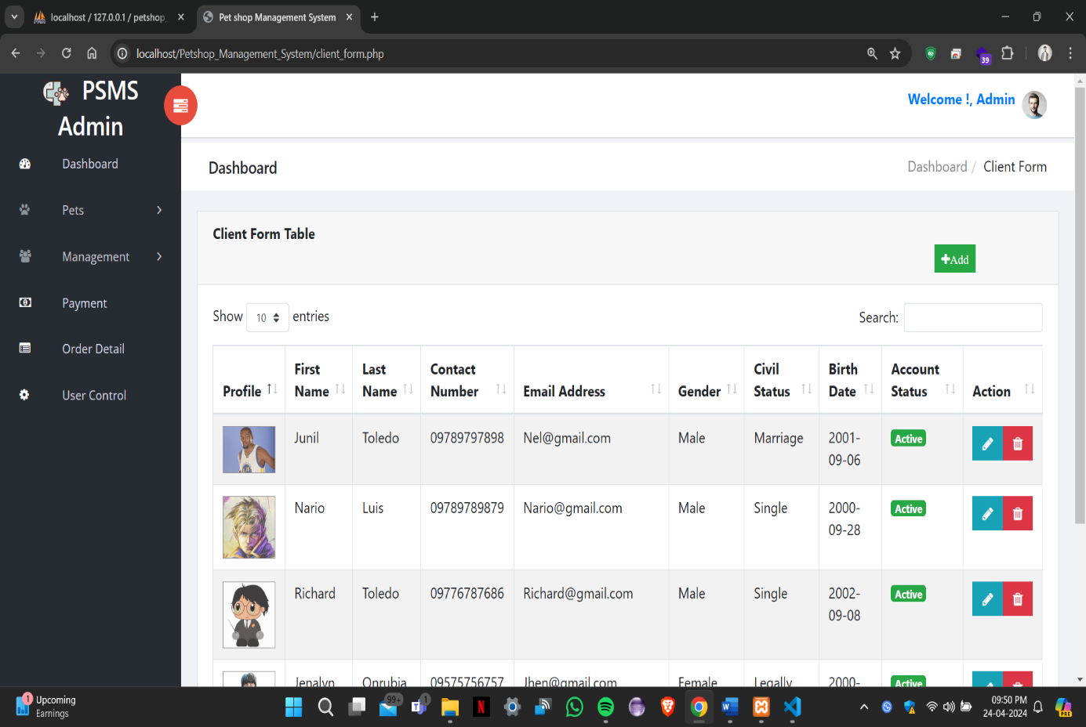

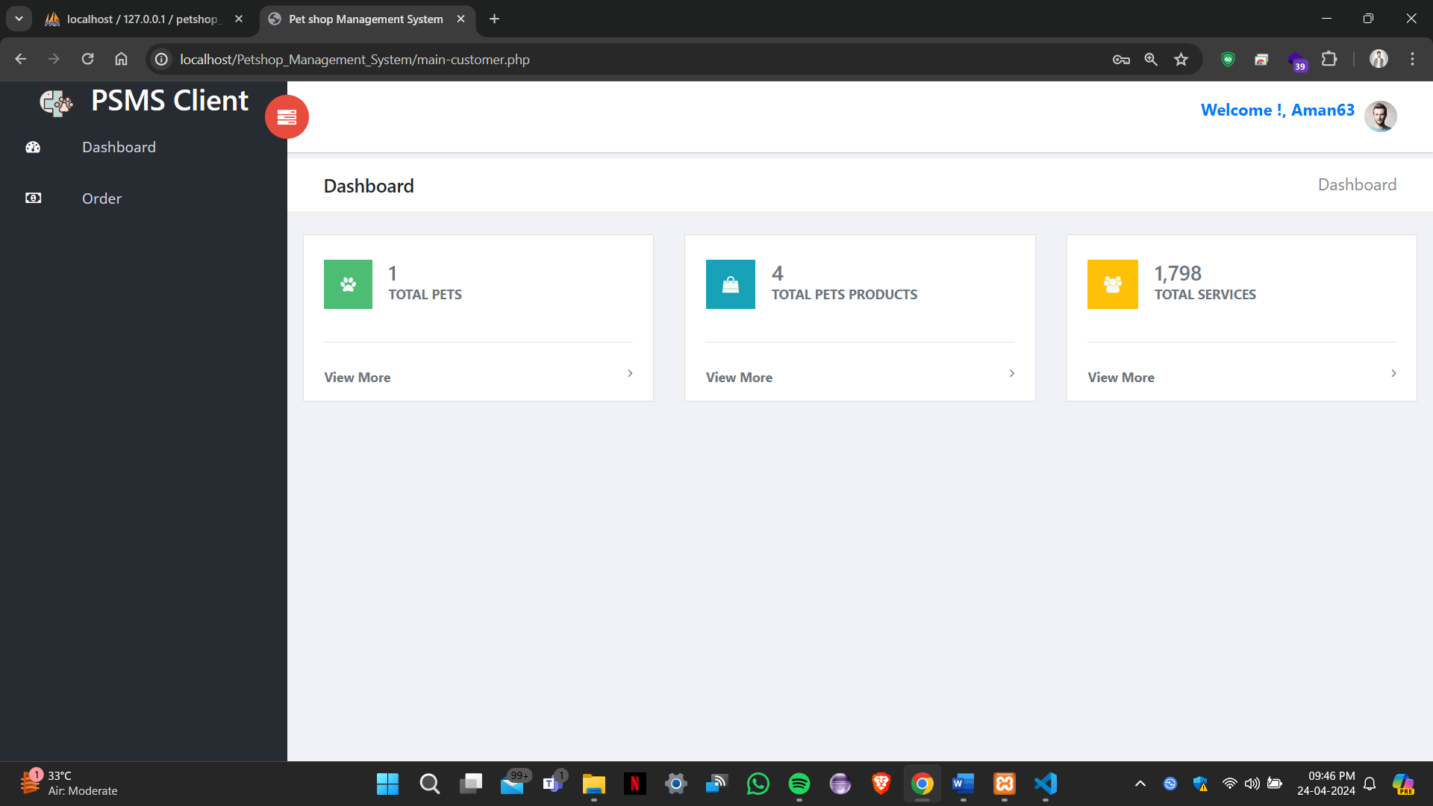

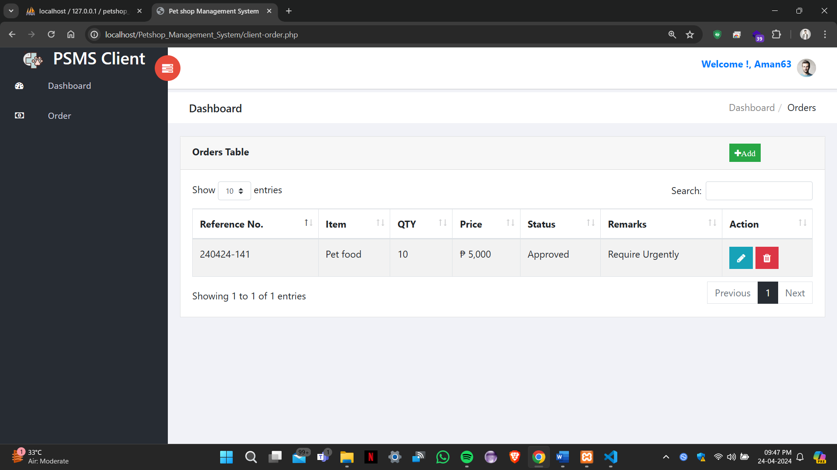

# 4 DRAWBACKS AND LIMITATION :

* **Assumptions and Predictions:** Feasibility studies rely on assumptions and predictions about various factors, including market conditions, costs, revenues, and technological advancements. These assumptions may not always accurately reflect the actual outcomes, leading to potential deviations from the study's findings.
* **Limited Scope:** Feasibility studies typically focus on specific aspects of a project, such as financial feasibility or technical feasibility. As a result, they may not capture the full complexity and inter dependencies of all project elements. This can lead to overlooked factors that could impact the project's success.
* **Uncertainty and Risk**: Feasibility studies involve assessing risks and uncertainties associated with the project. However, it is impossible to predict or account for all potential risks, and unexpected events or market shifts can occur, affecting the project's outcome.
* **Limited Data Availability**: Feasibility studies heavily rely on the availability and accuracy of data. In some cases, comprehensive and reliable data may be limited or difficult to obtain, making it challenging to make accurate projections and assessments.
* **Subjectivity:** Feasibility studies involve subjective judgments and interpretations based on the information available. Different stakeholders may have different perspectives and biases, which can influence the study's outcomes.
* **Lack of Flexibility:** Feasibility studies are typically conducted at the early stages of a project, when there is limited flexibility to make significant changes. As the project progresses, new information or insights may arise that could challenge the initial feasibility study's conclusions.

**5** **PROPOSED ENHANCEMENT :**

* Identify Current Limitations: Evaluate the existing project or system and identify its current limitations or areas that need improvement. This could be based on user feedback, performance issues, outdated technology, or any other factors that hinder the project's effectiveness.
* Gather Stakeholder Input: Engage with project stakeholders, including end-users, clients, and team members, to understand their needs and expectations. Gather feedback and suggestions from them to identify areas where enhancements are desired.
* Prioritize Enhancements: Assess the potential enhancements based on their impact, feasibility, and alignment with project goals. Prioritize the enhancements that offer the most significant benefits or address critical pain points.
* Cost and Resource Analysis: Evaluate the cost and resource requirements associated with each enhancement proposal. Consider factors like development effort, additional infrastructure, training, and ongoing maintenance. Assess the feasibility of implementing the enhancements within the project's constraints.
* Risk Assessment: Identify potential risks and challenges that could arise during the implementation of the enhancements. Develop mitigation strategies to address these risks and ensure smooth integration with existing systems or processes.
* Seek Stakeholder Approval: Present your enhancement proposals to the relevant stakeholders, such as project sponsors, management, or clients. Clearly communicate the value proposition and gain their support and approval for implementing the proposed enhancements.

**6. CONCLUSION :**

Through meticulous analysis and thoughtful design, we've embarked on the journey of creating an "Online Pet Shop" project, delving deep into the realm of computerization. Our unwavering commitment to realizing our objectives has been the guiding force throughout. At its core, our project aims to create a seamless platform for the procurement and exchange of pets, while also championing the noble cause of street dog adoption, facilitated in collaboration with NGOs.

The primary goals of our project are twofold: to eliminate intermediaries in pet transactions and to contribute towards the reduction of stray dog populations in public spaces. By cutting out the middleman, we aim to foster transparent and direct dealings, benefiting both buyers and sellers. Simultaneously, our initiative to facilitate street dog adoptions not only serves as a testament to our social responsibility but also strives to provide these animals with loving homes, thus addressing the issue of stray dog populations.

In our quest for excellence, we've ensured that our project is developed with future enhancements in mind. It is engineered to be both reliable and secure, laying a sturdy foundation for any forthcoming innovations. Moreover, the successful culmination of this endeavor has been nothing short of transformative. It has not only expanded the horizons of our imagination but has also instilled within us a newfound confidence, elevated our creativity, and endowed us with invaluable knowledge and experience.

As we press onward, we remain steadfast in our dedication to delivering a solution that not only meets but exceeds the expectations laid out during the analysis and design phases. Our "Online Pet Shop" project isn't merely a culmination of technical prowess; it's a testament to our unwavering commitment to leveraging technology for the betterment of society and the welfare of our furry companions.

**7 BIBLIOGRAPHY :**

* Animals information” Retrieved from - https://kids.nationalgeographic.com/animals “Animals (pet) photo” Retrieved form - <https://unsplash.com/s/photos/pets.>
* Java script- <https://code.visualstudio.com/>
* Language use for pet shop management system retrieved form PHP, Xampp Server- <https://www.apachefriends.org/index.html.>
* National Geographic Kids. "Animals information." Retrieved from: <https://kids.nationalgeographic.com/animals>
* Unsplash. "Animals (pet) photo." Retrieved from: <https://unsplash.com/s/photos/pets>
* Visual Studio Code. "JavaScript Development." Retrieved from: <https://code.visualstudio.com/>
* Apache Friends. "XAMPP Server." Retrieved from: <https://www.apachefriends.org/index.html>

**8 ANNEXURES :**

**User Management Module:**

1. **User Registration:**
   * To register and create an account, navigate to the registration page by clicking on the "Register" or "Sign Up" link.
   * Fill out the registration form with your personal details, including name, email address, and password.
   * Click on the "Register" button to submit the registration form.
   * Upon successful registration, you will receive a confirmation message, and your account will be created.
2. **User Login:**
   * To log into the system, navigate to the login page by clicking on the "Login" or "Sign In" link.
   * Enter your email address and password in the respective fields.
   * Click on the "Login" button to access your account.
   * If you are an administrator, ensure to use the designated admin login credentials to access the admin panel.
3. **Profile Management:**
   * After logging in, you can update your profile information by navigating to the profile settings page.
   * Here, you can edit your name, email address, password, and other personal details.
   * Make the necessary changes and click on the "Update Profile" button to save your modifications.
   * Ensure to keep your profile information up-to-date for seamless communication and account management.

**Pet Inventory Management Module:**

1. **Add Pet:**
   * To add a new pet to the inventory, navigate to the "Add Pet" section in the admin panel.
   * Fill out the required information for the pet, including breed, age, price, and availability.
   * Upload a clear and high-quality image of the pet to showcase it to potential customers.
   * Click on the "Add Pet" button to add the pet to the inventory.
2. **Update Pet Details:**
   * To update pet information, navigate to the "Manage Pets" section in the admin panel.
   * Locate the pet whose details you want to update and click on the "Edit" or "Update" button.
   * Modify the necessary information, such as breed, age, price, and availability.
   * Click on the "Save Changes" button to update the pet's details.
3. **Remove Pet:**
   * To remove a pet from the inventory, navigate to the "Manage Pets" section in the admin panel.
   * Locate the pet you wish to remove and click on the "Delete" or "Remove" button.
   * Confirm the deletion when prompted to remove the pet permanently from the inventory.

**Catalog and Search Module:**

1. **Pet Listing:**
   * The catalog displays a comprehensive list of available pets, showcasing their details and images.
   * Customers can browse through the catalog to view available pets and their attributes.
2. **Search Functionality:**
   * Customers can utilize the search functionality to find specific pets based on criteria such as breed, age, gender, or price range.
   * Enter the desired search criteria in the search bar and click on the search icon to retrieve relevant results.
3. **Filtering Options:**
   * Customers can refine their search results using filtering options provided on the catalog page.
   * Filter options may include breed, age, gender, price range, and availability

**Booking and Adoption Module:**

1. **Pet Booking:**
   * Customers interested in booking a pet can do so by navigating to the "Booking" or "Adoption" section.
   * Fill out the booking form with your contact information, including name, email address, and phone number.
   * Specify your preferences regarding the pet you wish to book, such as breed, age, and gender.
   * Submit the booking request by clicking on the "Book Now" or "Adopt" button.
   * Upon successful submission, you will receive a confirmation message with further instructions.
   * representative to complete the adoption process successfully.
2. **Availability Update:**
   * Once a pet is booked or adopted, its availability status will be updated in the inventory.
   * The pet will be marked as "Booked" or "Adopted," indicating that it is no longer available for booking or adoption.

**Order Management Module:**

1. **View Orders:**
   * Pet shop owners can view and manage customer orders by accessing the "Orders" or "Sales" section in the admin panel.
   * Here, you can view a list of all orders, including details such as order ID, customer information, and order status.
2. **Order Status Update:**
   * Pet shop owners can update the status of orders to keep track of their progress.
   * Common order statuses may include "Pending," "In Progress," "Shipped," and "Delivered."
   * To update the order status, locate the order in the admin panel and select the appropriate status from the dropdown menu.
3. **Invoice Generation:**
   * After an order is completed, pet shop owners can generate invoices or receipts for the transaction.
   * Navigate to the "Orders" or "Sales" section in the admin panel and select the order for which you want to generate an invoice.

**Reporting and Analytics Module:**

1. **Sales Reports:**
   * The system provides reports on sales performance, including revenue generated from pet sales.
   * Sales reports may include information such as total revenue, top-selling breeds, and trends in adoption rates.
2. **Inventory Reports:**
   * Generate reports on inventory status to monitor the availability of pets and track stock levels.
   * Inventory reports may include details such as available pets, sold pets, and remaining stock for each breed.
3. **Customer Analytics:**
   * Gain insights into customer behavior, preferences, and interactions through analytics tools.
   * Analyze customer data to identify trends, patterns, and areas for improvement in service delivery and customer satisfaction.

**Administrative Backend Module:**

1. **System Settings:**
   * Administrators can manage system configurations and settings to ensure optimal performance and security.
   * Access system settings to configure options such as email notifications, payment gateways, and security settings.
2. **User Management:**
   * Administrators have the authority to manage user accounts and permissions within the system.
   * Add, edit, or delete user accounts as needed and assign appropriate permissions based on user roles and responsibilities.
3. **Reports and Analytics:**
   * Administrators can access comprehensive reports and analytics tools to monitor system performance and user activity.
   * Analyze data to make informed decisions and drive improvements in pet shop management operations.

**9. SAMPLE CODE :**

<?php

  session_start();

    include_once('config/conn/db_connection.php');

    include_once('config/class/petshop_class.php');

if(!isset($_SESSION['logged_in']))

    {

       header("location:index.php");

    }else{

    $user_session = trim($_SESSION['user_no']);

    $fetch = new Petshop_class();

    $countpet = $fetch->count_pets();

    $countpetproducts = $fetch->count_petproducts();

    $countcountvendors = $fetch->count_vendors();

    $countservices = $fetch->count_services();

    $prices = $fetch->count_price();

?>

<?php include 'header/main-header.php';?>

    <div id="right-panel" class="right-panel">

        <!-- Header-->

        <header id="header" class="header">

            <div class="header-menu">

                <div class="col-sm-7">

                    <a id="menuToggle" class="menutoggle pull-left"><i class="fa fa fa-tasks"></i></a>

                </div>

                <div class="col-sm-5">

                    <div class="user-area dropdown float-right">

                       <a href="#" class="dropdown-toggle" data-toggle="dropdown" aria-haspopup="true" aria-expanded="false">

                             <strong style="color: #007bff;" class="mt-2">Welcome !, <?= ucfirst($user_session) ;?></strong> &nbsp;<img class="user-avatar rounded-circle" src="images/admin.jpg" alt="User Avatar">

                        </a>

                        <div class="user-menu dropdown-menu">

 <!--                            <a class="nav-link" href="#"><i class="fa fa-user"></i> My Profile</a>

                            <a class="nav-link" href="#"><i class="fa fa-cog"></i> Settings</a> -->

                            <a class="nav-link" href="logout.php"><i class="fa fa-power-off"></i> Logout</a>

                        </div>

                    </div>

                </div>

            </div>

        </header><!-- /header -->

        <!-- Header-->

        <div class="breadcrumbs">

            <div class="col-sm-4">

                <div class="page-header float-left">

                    <div class="page-title">

                        <h1>Dashboard</h1>

                    </div>

                </div>

            </div>

            <div class="col-sm-8">

                <div class="page-header float-right">

                    <div class="page-title">

                        <ol class="breadcrumb text-right">

                            <li><a href="main.php">Dashboard</a></li>

                        </ol>

                    </div>

                </div>

            </div>

        </div>

        <div class="content mt-3">

            <div class="animated fadeIn">

                <div class="row">

                    <div class="col-md-12">

                    </div>

                </div>

            </div><!-- .animated -->

        </div><!-- .content -->

 <!--/.col-->

    <div class="col-6 col-lg-3">

        <div class="card">

            <div class="card-body">

            <?php

                foreach($countpet as $pets){ ?>

                <div class="clearfix">

                    <i class="fa fa-paw bg-flat-color-5 p-3 font-2xl mr-3 float-left text-light"></i>

                    <div class="h5 text-secondary mb-0 mt-1"><?= htmlentities(number_format($pets['cat_name'])); ?></div>

                    <div class="text-muted text-uppercase font-weight-bold font-xs small">Total Pets</div>

                </div>

               <?php } ?>

                <div class="b-b-1 pt-3"></div>

                <hr>

                <div class="more-info pt-2" style="margin-bottom:-10px;">

                    <a class="font-weight-bold font-xs btn-block text-muted small" href="#">View More <i class="fa fa-angle-right float-right font-lg"></i></a>

                </div>

            </div>

        </div>

    </div>

    <!--/.col-->

    <div class="col-6 col-lg-3">

        <div class="card">

            <div class="card-body">

            <?php

                foreach($countpetproducts as $petproducts){ ?>

                <div class="clearfix">

                    <i class="fa fa-shopping-bag bg-info p-3 font-2xl mr-3 float-left text-light"></i>

                    <div class="h5 text-secondary mb-0 mt-1"><?= htmlentities(number_format($petproducts['pro_name'])); ?></div>

                    <div class="text-muted text-uppercase font-weight-bold font-xs small">Total Pets Products</div>

                </div>

                <?php } ?>

                <div class="b-b-1 pt-3"></div>

                <hr>

                <div class="more-info pt-2" style="margin-bottom:-10px;">

                    <a class="font-weight-bold font-xs btn-block text-muted small" href="#">View More <i class="fa fa-angle-right float-right font-lg"></i></a>

                </div>

            </div>

        </div>

    </div>

    <!--/.col-->

    <div class="col-6 col-lg-3">

        <div class="card">

            <div class="card-body">

             <?php

                foreach($countcountvendors as $vendors){ ?>

                <div class="clearfix">

                    <i class="fa fa-users bg-warning p-3 font-2xl mr-3 float-left text-light"></i>

                    <div class="h5 text-secondary mb-0 mt-1"><?= htmlentities(number_format($vendors['uname'])); ?></div>

                    <div class="text-muted text-uppercase font-weight-bold font-xs small">Total Vendors</div>

                </div>

                 <?php } ?>

                <div class="b-b-1 pt-3"></div>

                <hr>

                <div class="more-info pt-2" style="margin-bottom:-10px;">

                    <a class="font-weight-bold font-xs btn-block text-muted small" href="#">View More <i class="fa fa-angle-right float-right font-lg"></i></a>

                </div>

            </div>

        </div>

    </div>

    <!--/.col-->

    <div class="col-6 col-lg-3">

        <div class="card">

            <div class="card-body">

              <?php

                $total = 0;

                foreach ($prices as $rows):

                    $total += htmlentities($rows['qty']) * htmlentities($rows['price']); ///for order table compute

              ?>

             <?php

                $tota2l = 0;

                foreach ($countservices as $row):

                        $total2 = htmlentities($row['s_fee']); ///for service table compute

              ?>

             <?php endforeach ?>

             <?php endforeach ?>

                <div class="clearfix">

                    <i class="fa fa-money bg-danger p-3 font-2xl mr-3 float-left text-light"></i>

                    <div class="h5 text-secondary mb-0 mt-1"><?= number_format(($total) + ($total2),2); ?></div>

                    <div class="text-muted text-uppercase font-weight-bold font-xs small">Total Income</div>

                </div>

                <div class="b-b-1 pt-3"></div>

                <hr>

                <div class="more-info pt-2" style="margin-bottom:-10px;">

                    <a class="font-weight-bold font-xs btn-block text-muted small" href="#">View More <i class="fa fa-angle-right float-right font-lg"></i></a>

                </div>

            </div>

        </div>

    </div>

    <!--/.col-->

<?php } ?>

    </div><!-- /#right-panel -->

    <!-- Right Panel -->

    <script src="vendors/jquery/dist/jquery.min.js"></script>

    <script src="vendors/popper.js/dist/umd/popper.min.js"></script>

    <script src="vendors/bootstrap/dist/js/bootstrap.min.js"></script>

    <script src="assets/js/main.js"></script>

    <script src="vendors/datatables.net/js/jquery.dataTables.min.js"></script>

    <script src="vendors/datatables.net-bs4/js/dataTables.bootstrap4.min.js"></script>

    <script src="vendors/datatables.net-buttons/js/dataTables.buttons.min.js"></script>

    <script src="vendors/datatables.net-buttons-bs4/js/buttons.bootstrap4.min.js"></script>

    <script src="vendors/jszip/dist/jszip.min.js"></script>

    <script src="vendors/pdfmake/build/pdfmake.min.js"></script>

    <script src="vendors/pdfmake/build/vfs_fonts.js"></script>

    <script src="vendors/datatables.net-buttons/js/buttons.colVis.min.js"></script>

    <script src="assets/js/init-scripts/data-table/datatables-init.js"></script>

</body>

</html>